Logbook 1 (for offline log preparation)
Name: | Yvette Lee EnQi
Week Date: | Part A -Meeting 1 of 8
(The above information is for you to keep track of which week this log is applicable for. This information is not required in the online logbook as the system will find your name, your supervisor’s name, and take the submission date, automatically. You must submit the online log in the relevant week. Logs cannot be backdated to missed weeks.)

Meeting date:  (please note if no meeting is planned this week) | 26/05/2026
Work Undertaken this week:  (No more than 4000 characters, including spaces) | - Bawden et al. (2017) — Robot for Weed Species Plant-Specific Management  Developed a ground-based robot for targeted weed management using machine vision and precision spraying. The system uses a camera and real-time image processing to distinguish crops from weeds, then activates individual nozzles. Relevance: Demonstrates that vision-based plant classification is viable on mobile platforms but focuses on intervention (spraying) rather than monitoring.  - TerraSentia (EarthSense / University of Illinois)  A compact, low-cost under-canopy robot designed for crop phenotyping and stand counting. It uses RGB cameras and basic odometry to autonomously navigate between corn and soybean rows. It is lightweight (~10 kg) and commercially available. Relevance: Validates the feasibility of small, camera-only monitoring robots. However, it relies on simple odometry and lacks onboard AI inference.  - Thorvald II (Saga Robotics)  A modular agricultural platform used for crop monitoring, UV-C mildew treatment, and data collection. It uses LiDAR and GNSS for navigation and can carry heavy payloads. Relevance: Proves robust navigation in outdoor farm environments, but the platform is large, expensive, and over-engineered for simple monitoring.  - Yang et al. (2024) — Hokkaido University Grape-Harvesting Robot  Developed a multi-camera vision system for cut-point detection on a harvesting robot, achieving 93% accuracy in outdoor conditions using embedded AI. The lab also has extensive GNSS-IMU fusion experience for large tractors (Ospina & Noguchi, 2020).
Problems encountered:  (No more than 4000 characters, including spaces) | - Base Robot Selection: The lab inventory lists both TurtleBot3 Burger and Jupiter Robot with LiDAR. I need supervisor confirmation on which platform to use as the primary chassis. The TurtleBot3 is compact and well-supported under ROS2 Humble, while the Jupiter Robot includes integrated LiDAR that could simplify navigation  - GPS and wheel odometry, but my system block diagram assumes a 9-DOF IMU for robust heading estimation between crop rows. I need to confirm whether the lab has a compatible IMU module (e.g., MPU9250 or BNO055) available, or if I should design the navigation stack to function without one at this stage and treat IMU fusion as a future enhancement.  - ROS2 Humble Hardware Compatibility: While my development laptop runs Ubuntu 22.04 with ROS2 Humble, I need to verify that the motor controller firmware and USB-to-serial interfaces on the selected base robot are fully compatible with Humble, or whether the lab standardises on an older ROS2 distribution that would require a dual-boot or container setup.  - Need to confirm expected ROS2 node architecture and whether the project should use custom Python nodes or standard packages like nav2, robot_localization, etc.
Tasks agreed for upcoming week:  (No more than 4000 characters, including spaces) | I could do up my research scopes, read up more about the environment of farms and greenhouses in Singapore to be able to have a more accurate target of what the robot should be like. I can try to find and analyse the different types of robot/autonomous vehicles that are currently available and how people go about designing it and the research behind it.
Figures:  (Upload image files in the online Log Form, but feel free to keep notes here about which images you intend to upload. Use “Figure Caption” information as the filenames, e.g., “Figure 1 – A screenshot of the initial constrained Sketch in CATIA.jpg”) | - Provide / Sketch an artistic view of your project. A rough one will do. You can use any software like PPT to design this sketch  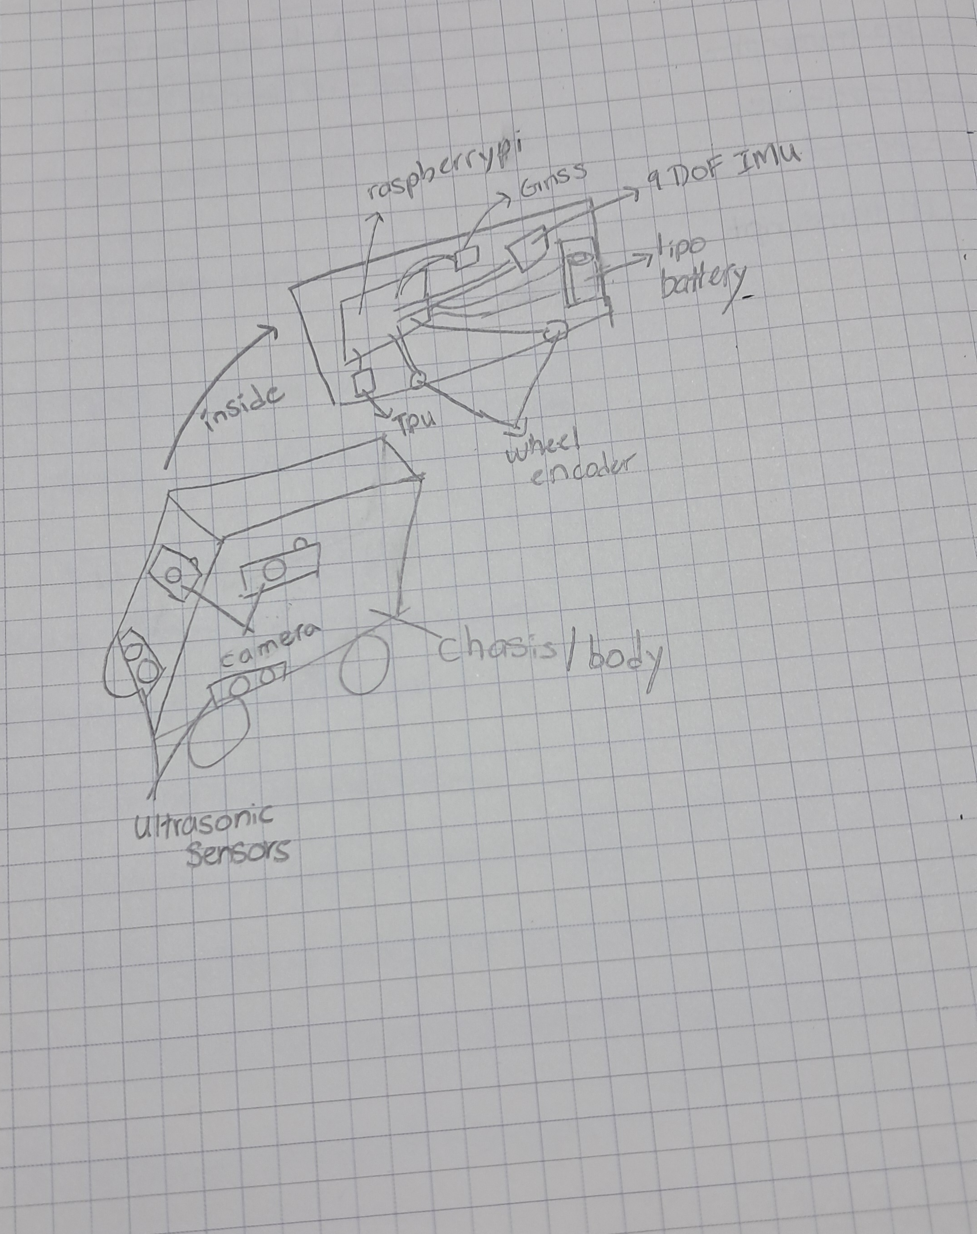  - Block diagram of your system  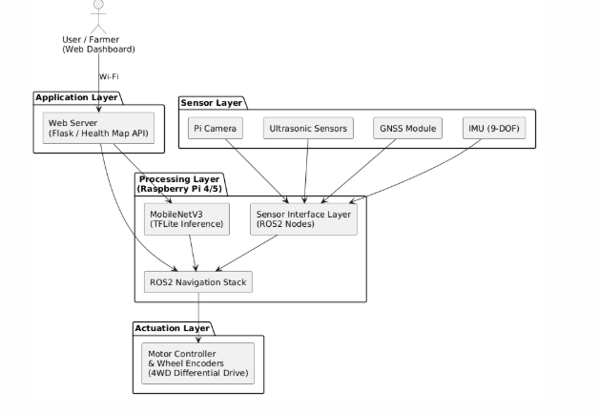  - Key software codes/modules that need to be developed  The following is a proposed software architecture based on standard ROS2 robotics patterns and the project requirements. Node names, languages, and specific packages are subject to review and alignment with lab standards.  - Any Quality and Regulatory issued to be addressed?
  Module | Language | Platform / Framework | Description
  nav_waypoint_node | Python | ROS2 | Subscribes to GNSS/IMU/encoder topics, publishes cmd_vel for row following
  ekf_fusion_node | Python / C++ | ROS2 robot_localization | Fuses sensor data into /odometry/filtered
  capture_and_classify | Python | ROS2 + TensorFlow Lite | Captures image at waypoint stop, runs MobileNetV3, publishes health label
  obstacle_watchdog | Python | ROS2 | Monitors ultrasonic range, publishes emergency stop if distance < threshold
  field_health_server | Python | Flask / FastAPI | Receives GPS + health data, serves web dashboard with Leaflet / Mapbox map
  dataset_pipeline | Python | OpenCV + Pillow | Pre-processes captured images, augments data, exports TFLite training format

